Chapter 9, Solution 30.

Since R and C are in parallel, they have the same voltage across them. For the resistor,
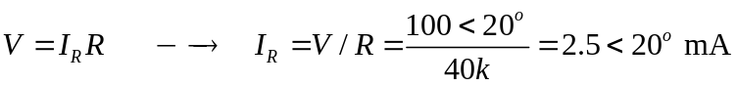
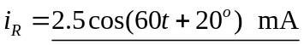

For the capacitor,

